732A54: Big Data Analytics - Lab BDA2 – Spark SQL

*Umamaheswarababu Maddela (umama339)*

*Dinesh Sundaramoorthy (dinsu875)*

**Assignment-1:**

**Code:**

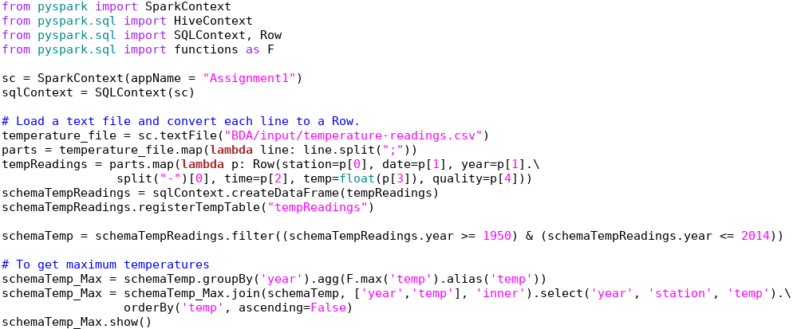 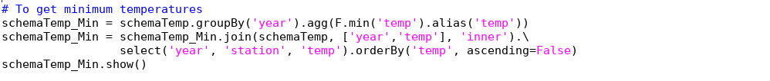

**Output:**

**## Maximum Temperatures**

year, station with the max, maxValue ORDER BY maxValue DESC

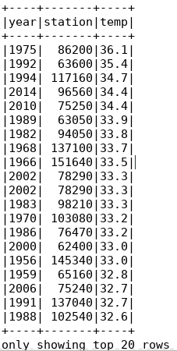

**## Minimum Temperatures**

year, station with the min, minValue ORDER BY minValue DESC

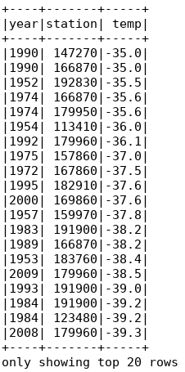

**Assignment-2:**

Count the number of readings for each month in the period of 1950-2014 which are higher than10degrees

**Code:**

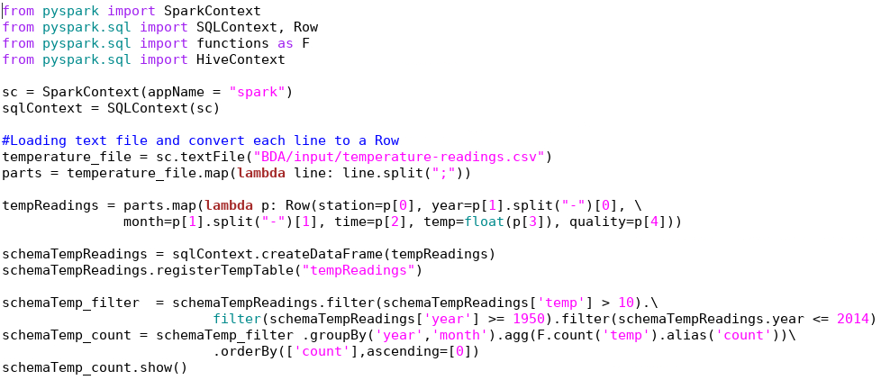

**Output:**

year, month, value ORDER BY value DESC

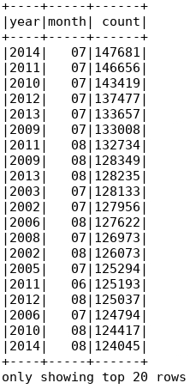

Taking only distinct readings from each station

**Code:**

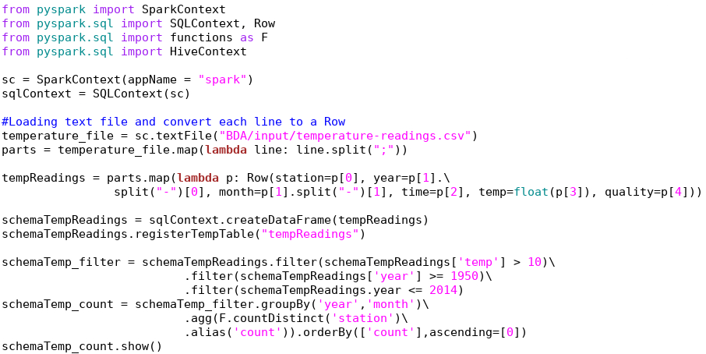

**Output:**

year, month, value ORDER BY value DESC

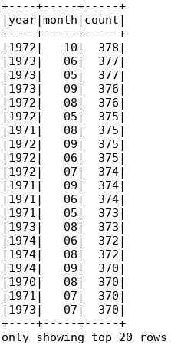

**Assignment-3:**

year, month, station, avgMonthlyTemperature ORDER BY avgMonthlyTemperature DESC

**Code:**

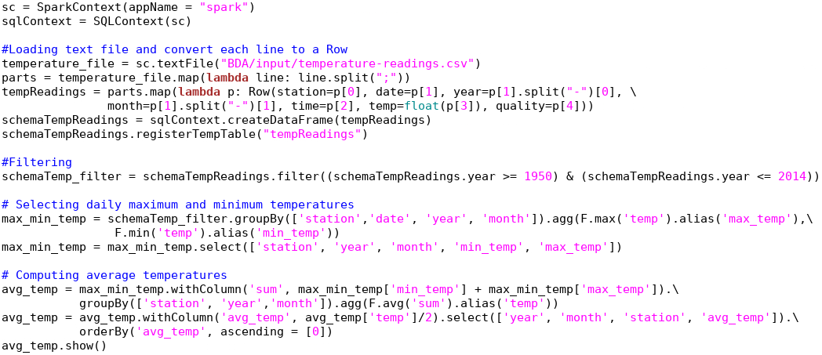

**Output:**

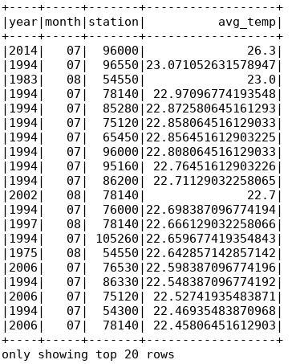

**Assignment-4:**

station, maxTemp, maxDailyPrecipitation ORDER BY station DESC

**Code:**

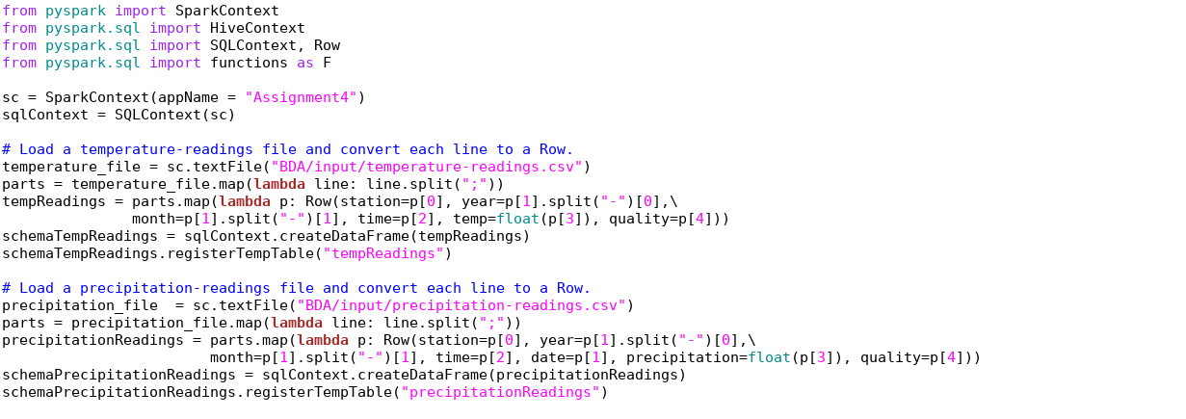

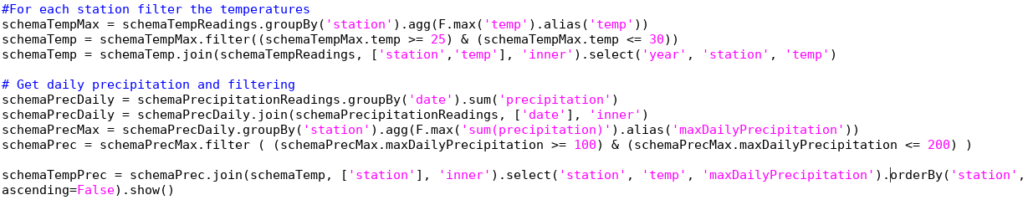

**Output:**

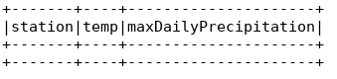

**Assignment-5:**

year, month, avgMonthlyPrecipitation ORDER BY year DESC, month DESC

**Code:**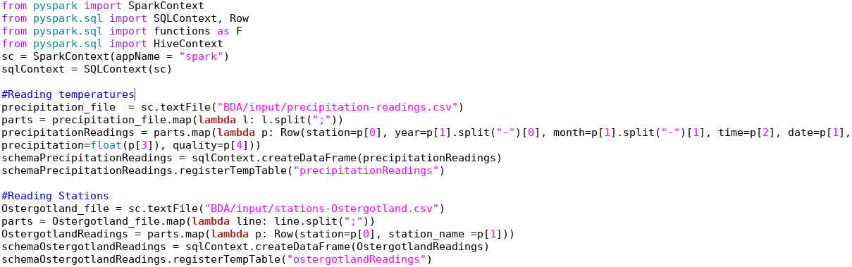

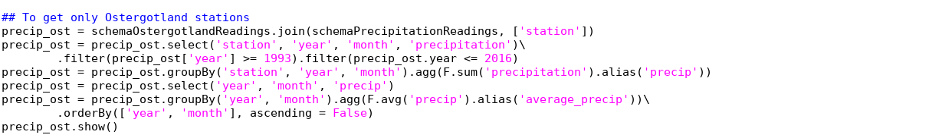

**Output:**

